**Day 29:**

Eureka server keep the track or health of all micro service deploy using same or different language.

1st Project: Eureka Server

Starter -🡪Eureka Starter

Starter 🡪 Web Starter

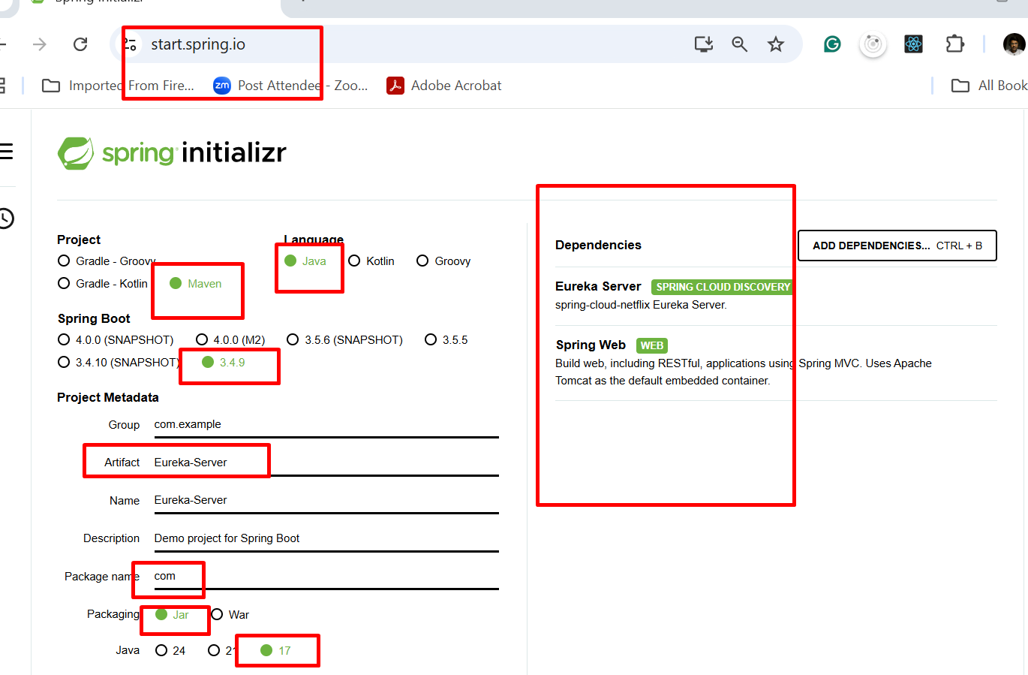

By default tomcat run on server 8080. This project contains eureka server so eureka server start on 8080.

But whenever we create one or more than one micro service by default each micro service project search eureka server on 8761 port number. 8761 is default port number for eureka server.

4th Project: 3rd Micro Service Project: Creating Account Micro Service

Port number 8383

Starter 🡪 Web Starter

Starter 🡪Eureka discovery client

Starter -🡪 JPA Starter

Starter 🡪 My SQL Dependency

Starer 🡪 devtool : auto re-load features

End Point 🡪 Post Method to create the Account

End point 🡪 Get method get amount using accno (PK)

End Point 🡪 Get method : get accno number emailid (unique) using custom method.

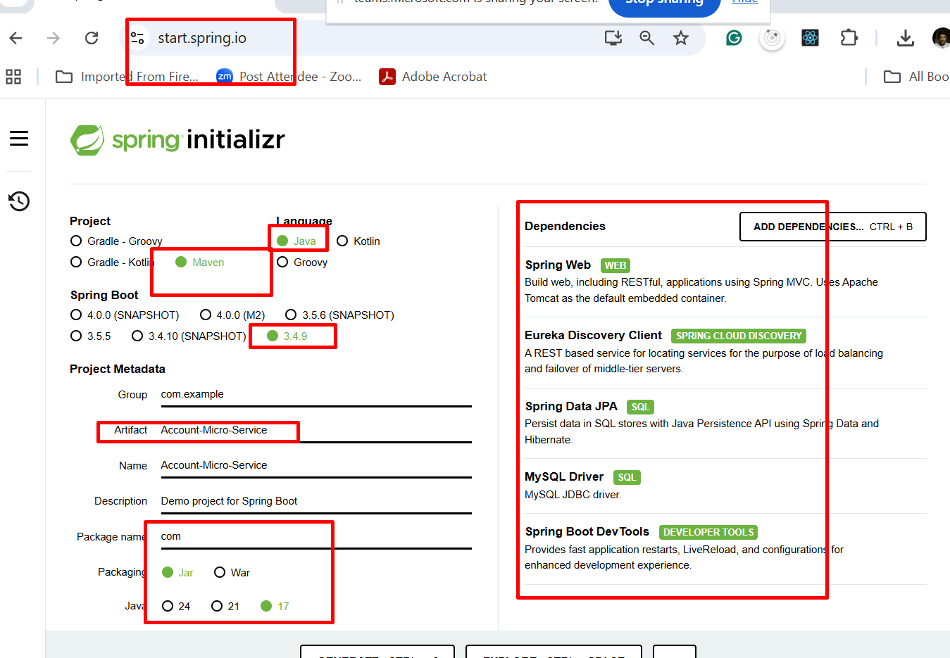

**@RequestMapping** annotation we can use on class level as well as method level with method attribute as GET, POST, PUT or DELETE.

Class level use to map main root path.

@GetMapping

@PostMapping

@DeleteMapping

@PutMapping

@PatchMapping these all annotation is method level annotation with meaning full name without method attribute.

5th Project: 4th Micro Service Project: PhonePay micro Service

Port number 8484

Starter 🡪 Web Starter

Starter 🡪Eureka discovery client

Starter -🡪 JPA Starter

Starter 🡪H2 (spring boot provided in memory database).

End Point 🡪 Post Method to PhonePay account

Pid 🡪 PK with auto increment,

AccNo 🡪

EmailId : 🡪 unique key

This end point receive emailId and communicate with Account micro service running on port number 8383 and get accno number. If account present create account.

End point 🡪 Get method : if want PID and get amount. Using pid we get account number if account number present. That account pass to account micro service to the amount etc.

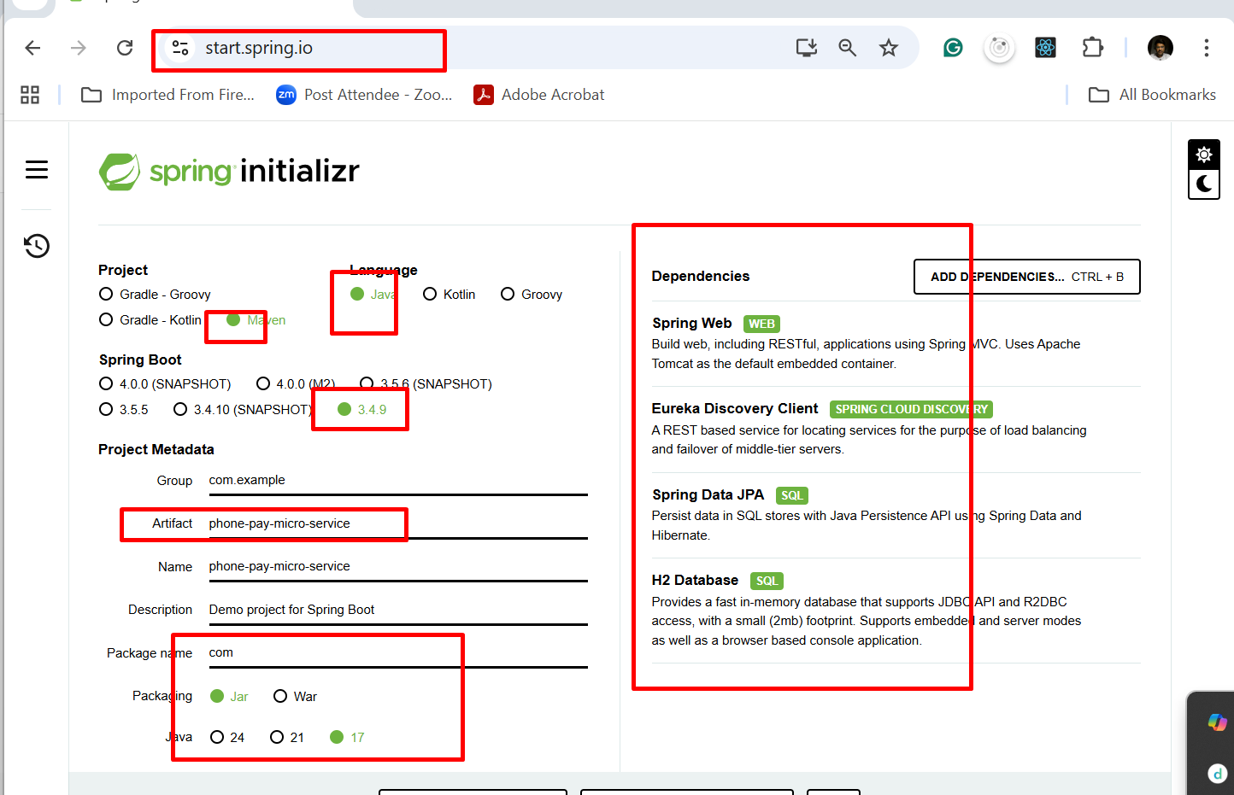

**RestTemplate** is a API provided java which help to call another rest full web service develop using same language or different language.

To open H2 database on browser mode

<http://localhost:portNumber/h2-console>